Muhammad Ahtir Saeed

22-10337

COMP-421-B

**1: Screenshot of zenmap tool to show the open / running ports on your own IP address / host**

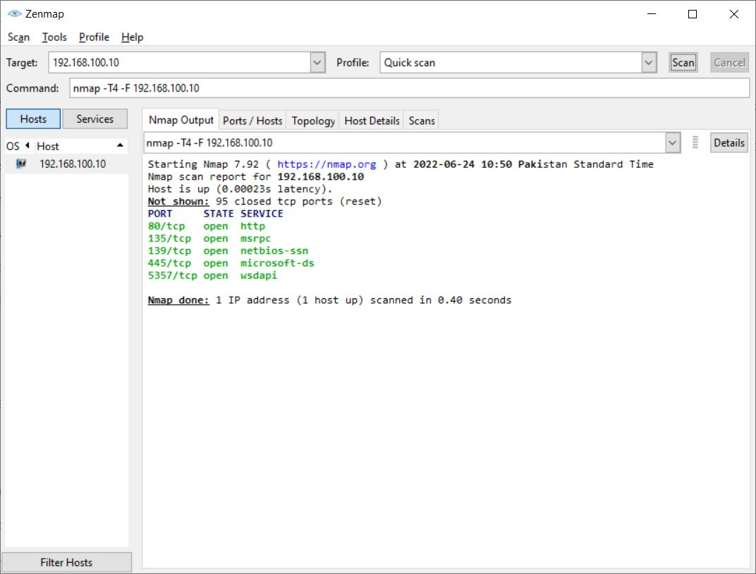

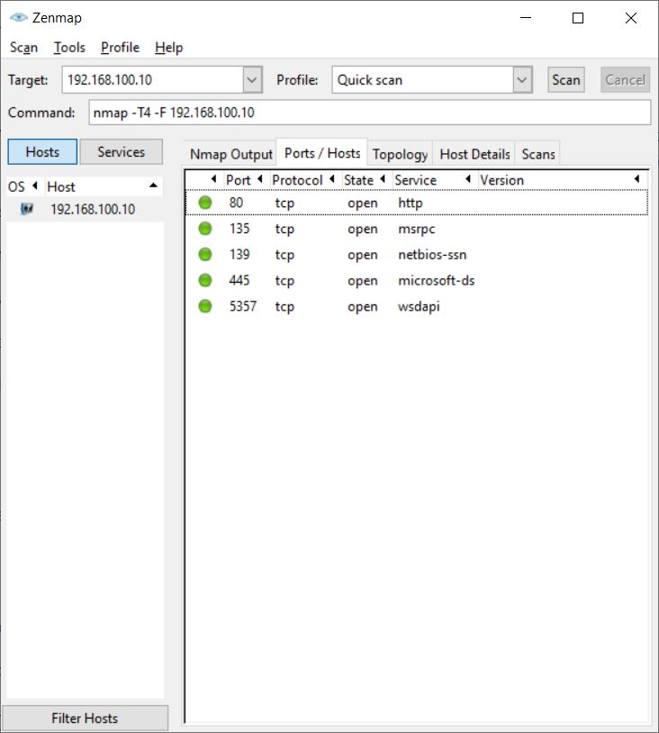

**2: Screen to indicate a new rule to block any one port of your choice**

Rule in firewall

Inbound:

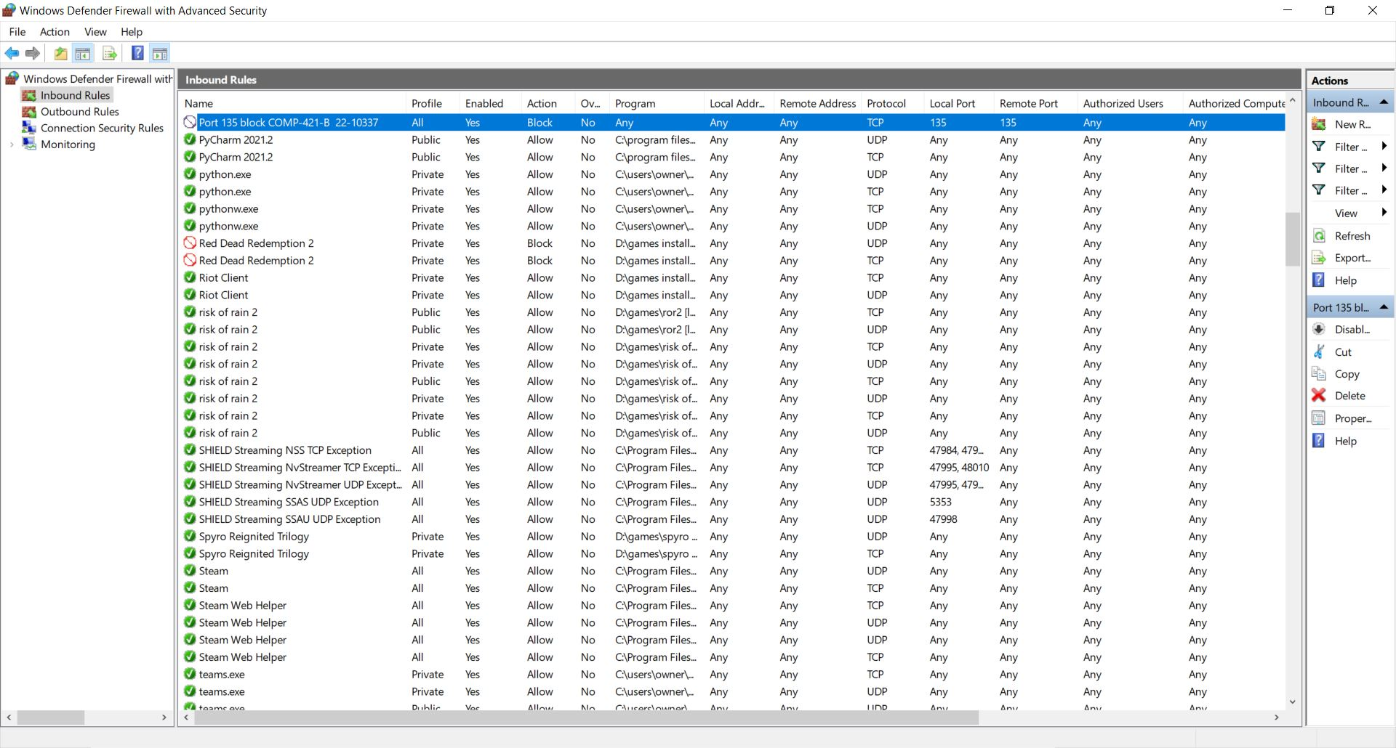

Outbound:

